Core Concepts Covered
Feature | Environment Variables | ConfigMap | Secret
Purpose | Static config per Pod | Externalized non-sensitive config | Externalized sensitive config
Sensitivity | Not secure | Not secure | Base64-encoded, secure
Storage | Inline in Pod spec | Separate object | Separate object
Use in Pod | env or envFrom | env, envFrom, volume mount | env, envFrom, volume mount
Typical Use Case | Port, mode, flags | App config, URLs, feature flags | DB passwords, API keys,  tokens

- Environment Variables in Pods:
  - Initially, environment variables were directly embedded in Pod YAML files as key-value pairs.
  - This approach becomes unmanageable when environment variables grow in number or need to be shared among multiple pods or containers.
- ConfigMaps:
  - Best practice: Move environment variables out of pod specs into a separate ConfigMap object.
  - ConfigMap stores key-value pairs which can be injected into pods.
  - This separation promotes reusability and consistency across multiple pods.
- Methods to Create ConfigMaps:
  - Imperative Approach:
    - Using kubectl create configmap command with --from-literal for individual key-value pairs.
    - Example syntax:
kubectl create configmap app-cm --from-literal=firstName=PC --from-literal=lastName=Ch
    - ConfigMaps can also be created from a file using --from-file. From multiple files, directory also possible.
kubectl create configmap app-cm –from-file=app.config
Inside file we can have key value pairs
APP_MODE=production
PORT=8080
    - kubectl get configmap OR kubectl get cm -> list configmaps
    - kubectl describe cm/app-cm -> describe the config map to see name, namespace, labels, annotations, data.
  - Declarative Approach:
    - Generate YAML manifests of ConfigMaps using a dry-run command:
kubectl create configmap app-cm --from-literal=firstName=PC --dry-run=client -o yaml > cm.yaml
    - Edit and apply the YAML manifest using kubectl apply -f cm.yaml.
- Injecting ConfigMaps into Pods:
  - Inject environment variables individually using env with valueFrom.configMapKeyRef.
  - Inject all environment variables at once using envFrom.configMapRef for efficiency—ideal when many variables exist.
  - ConfigMaps can also be mounted as volumes.
- Updating ConfigMaps:
  - Changes to ConfigMaps require either:
    - Re-applying with --force or
    - Deleting and recreating pods to reflect new values.
- ConfigMaps are immutable at runtime: changes require pod recreation or forced updates.
- Mounting ConfigMaps as volumes is possible.

Secrets:
kubectl create secret generic db-secret --from-literal=DB_USER=admin –from-literal=DB_PASS=secret123
By default: Kubernetes Secrets are stored in etcd as Base64-encoded strings, not encrypted.
- Base64 is just encoding, not security — anyone with access can decode easily.
- For real security:
- Enable encryption at rest in Kubernetes (encrypts Secrets in etcd).
- Use external secret managers (e.g., HashiCorp Vault, AWS Secrets Manager, Azure Key Vault).
- Restrict access with RBAC so only authorized Pods/users can read Secrets.

Definitions
Term | Definition
ConfigMap | Kubernetes object to store non-confidential key-value pairs used for configuration management.
Secret | Kubernetes object to store sensitive data like passwords or tokens.
env | Pod spec field to define individual environment variables for containers.
valueFrom | A way to reference values from ConfigMaps or Secrets in environment variables.
envFrom | A shorthand to load all key-value pairs from a ConfigMap or Secret into environment variables.

- Use ConfigMaps for non-sensitive config that may change frequently.
- Use Secrets for credentials and sensitive values — avoid hardcoding.
- Use environment variables for static values or quick overrides.
- Avoid putting secrets in ConfigMaps — they are not encrypted.
They all can be used together (or separately).
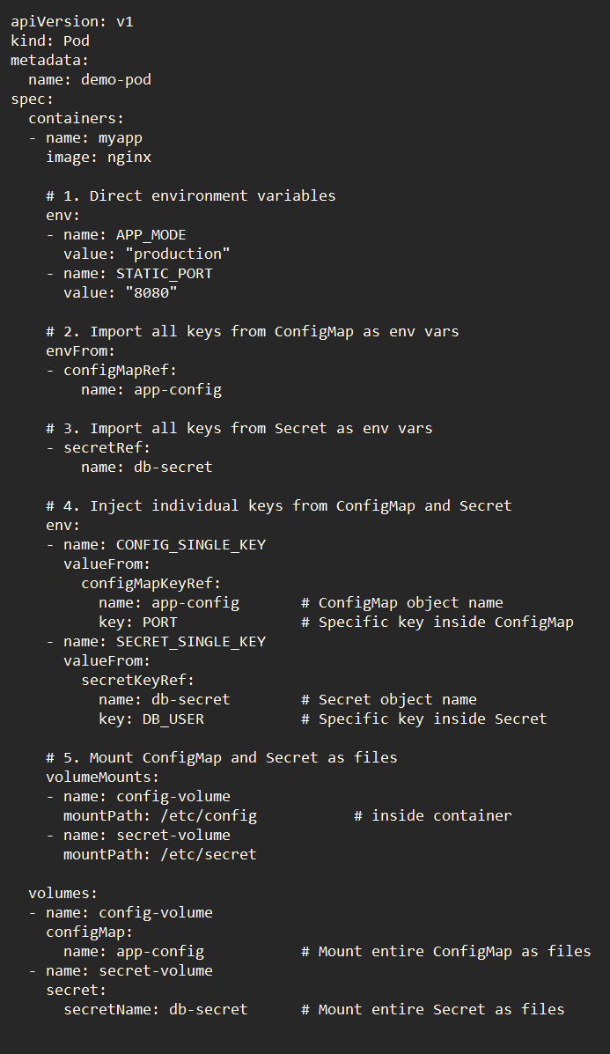

Instead of “spec”, we have “data”.
